
YARD DUTY AND SUPERVISION POLICY
PURPOSE
To ensure school staff understand their supervision and yard duty responsibilities.
SCOPE
Adequate supervision of students in the school yard is a requirement of the school’s duty of care. We aim to provide adequate and appropriate supervision of students in the school yard.
The principal is responsible for ensuring that there is a well-organised and responsive system of supervision in place during school hours, before and after school, and on school excursions and camps.
This policy applies to all teaching and non-teaching staff at Wandin North Primary School, including education support staff, casual relief teachers and visiting teachers.
School staff are responsible for following reasonable and lawful instructions from the principal, including instructions to provide supervision to students at specific dates, time and places. Supervision should be undertaken in a way that identifies and mitigates risks to child safety.
POLICY

Before and after school
Wandin North Primary School’s grounds are supervised by school staff from 8:45 until 3:45. Outside of these hours, school staff will not be available to supervise students. Parents and carers will be informed regularly via our newsletter that staff members are not rostered to take yard before 8:45am each morning or after 3:45pm each day. Parents and carers are discouraged from sending their children to school outside of supervised yard duty times and are required to make sure that their children have been collected or have left the school grounds by 3:45.
Families are encouraged to contact TheirCare on 1300 072 410 or refer to www.theircare.com.au for more information about the before and after school care facilities available to our school community.
A student who arrive at school before supervision commences at the beginning of the day will be brought to the office. The Office Staff, Principal or Assistant Principal, will, as soon as practicable, follow up with the parent/carer to:
- advise of the supervision arrangements before school
- request that the parent/ carer make alternate arrangements
- offer details for the TheirCare out of hours care program
If a student is not collected before supervision finishes at the end of the day, the principal or nominee staff member will consider whether it is appropriate to:
- attempt to contact the parents/carers
- attempt to contact the emergency contacts
- place the student in our TheirCare out of hours care program
- contact Victoria Police and/or the Department of Health and Human Services (Child Protection) to arrange for the supervision, care and protection of the student
School staff who are rostered on for before or after school supervision must follow the processes outlined below.

Yard duty
Supervision of students is the responsibility of all staff at Wandin North Primary School. Yard supervision will include before school, recess and lunch breaks, and after school. Staff are expected to assist with yard duty supervision as detailed in the yard duty roster. The yard supervision roster will basically require staff members to undertake yard duty before school, for half of recess or half of lunchtime, or after school on specific days. The Assistant Principal will be responsible for coordinating, preparing and communicating the roster, and for negotiating specific duty times or days with individual staff members.

School staff will be designated a specific yard duty area to supervise. The roster will require a minimum of three staff members on duty at any one time, each responsible for supervising a designated area of the school.

Casual Relief Teachers will also be responsible for the yard duty responsibilities of staff members they are replacing.

In addition, Level 2 first aid trained staff members will be responsible for supervision of the first aid room during recess and lunch times.

The designated yard duty areas for our school as at February 2021 are:

Zone | Area
Zone A | Adventure Playground
Zone B | Buildings and Surrounds
Zone C | Basketball Court and Oval
Zone D | Playground and Surrounds
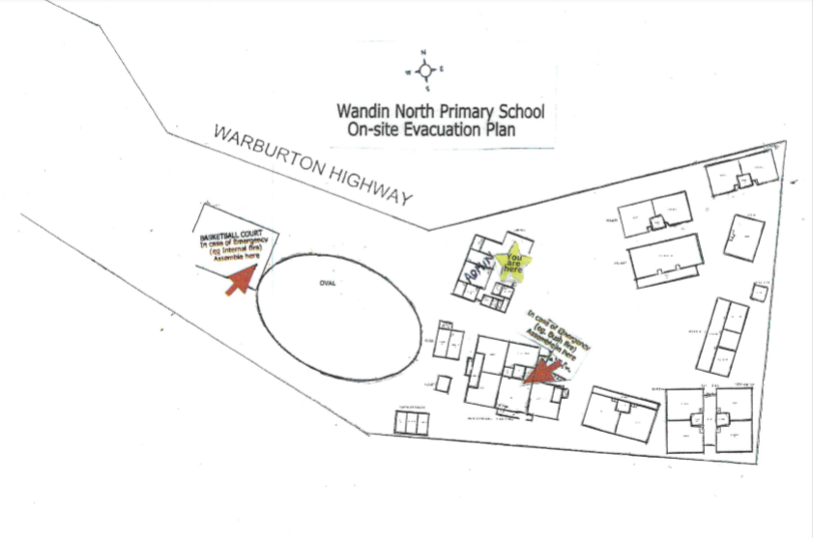
WANDIN NORTH PRIMARY SCHOOL MAP WITH YARD DUTY ZONES MARKED:

A
B
C
D
Yard Duty Equipment:
School staff on Yard Duty must:
- wear a provided safety/hi-vis vest
- carry a bum bag containing basic first aid supplies
- store their equipment and maintain/restock their first aid bum-bags supplies
- be familiar with the student medical information displayed in CRT folders, classroom and first aid room
Yard Duty Responsibilities:
Staff who are rostered for yard duty must remain in the designated area until they are replaced by a relieving teacher.
During yard duty, supervising staff must:
- be prompt at arriving at their yard duty location on time, and must ensure that all students have left the yard before completing their rostered duty
- methodically move around the designated zone ensuring active supervision of all students
- approach intruders or unknown people in the yard
- be alert and vigilant
- intervene immediately if potentially dangerous or inappropriate behaviour is observed in the yard
- model Sun Smart behaviours, including wearing a hat and sunscreen during periods of hot weather
- enforce behavioural standards and implement appropriate consequences for breaches of safety rules, in accordance with any relevant disciplinary measures set out in Wandin North Primary School’s Student Engagement and Wellbeing policy
- ensure that students who require first aid assistance receive it as soon as practicable
- log any incidents or near misses as appropriate on Compass chronicle and inform/consult classroom teachers or leadership if required
- if being relieved of their yard duty shift by another staff member (as our lunch and recess breaks are ‘split’ into 2 consecutive time periods), staff must ensure that a brief but adequate verbal ‘handover’ is given to the next staff member in relation to any issues which may have arisen during the first shift
- where safe to do so, approach any unknown visitor who is observed on school grounds without a clear legitimate purpose, and ensure they have a visitor pass and have signed in (excluding drop off and collection periods)
If the supervising staff member is unable to conduct yard duty at the designated time, they are required to either make a swap with another staff member or contact the Assistant Principal. Staff are to provide as much notice as possible prior to the relevant yard duty shift to ensure that alternative arrangements are made.
If the supervising staff member needs to leave yard duty during the allocated time, they should contact the Assistant Principal but should not leave the designated area until the relieving staff member has arrived in the designated area.
Students who require assistance during recess or lunchtime are encouraged to speak to the supervising yard duty staff member.

Classroom
The classroom teacher is responsible for the supervision of all students in their care during class.
If a teacher needs to leave the classroom unattended at any time during a lesson, they should first contact their Year Level Coordinator or School office to organise assistance. The teacher must then wait until another staff member has arrived at the classroom to supervise the class prior to leaving.

School activities, camps and excursions
The principal and leadership team are responsible for ensuring that students are appropriately supervised during all school activities, camps and excursions, including when external providers are engaged to conduct part or all of the activities. Event coordinators must ensure staff to student ration is listed and list volunteers when planning events on Compass. The Principal will only approve events where appropriate supervision has been planned. This is required for special school activities, camps and excursions on an individual basis, depending on the activities to be undertaken and the level of potential risk involved.
COMMUNICATION
This policy will be communicated to our school community in the following ways:
- Included in staff induction processes
- Discussed at staff briefings or meetings, as required
- Included in staff handbook
- Made available in hard copy form school administration upon request

Information for parents and students on supervision before and after school is available on our school website.

FURTHER INFORMATION AND RESOURCES
- the Department’s Policy and Advisory Library:
  - Supervision of Students
  - Duty of Care
  - Child Safe Standards
  - Visitors in Schools
POLICY REVIEW AND APPROVAL
Policy last reviewed | February 2026
Approved by | Assistant Principal Amanda Dunn
Next scheduled review date | February 2028
This policy will also be updated if significant changes are made to school grounds that require a revision of Wandin North Primary School’s yard duty and supervision arrangements.

